SERVICENOW PROJECT SUBMISSON

Tailored Application Access for Enhanced User Experience

# Submitted by

CHAGANTI INDRA au723921243009

PALEM HEMANTH REDDY au723921243039

KONDURU JAYASIMHA REDDY au72392124302

EDURU PRANESH au723921243017

Arjun College of Technology, Coimbatore

Anna University Chennai -600 025

**Tailored Application Access for Enhanced User Experience**

**Project Overview:**

To design and implement a tailored access control system within GlobalTech Solutions' ServiceNow instance that provides employees with role-specific applications and modules, thereby reducing confusion and improving operational efficiency.

**Objectives:**

**1. Value: Personalized User Access for Greater Relevance**

* **Objective:** Provide users with access to only the features, content, and tools that are most valuable and relevant to their specific needs, roles, and goals.
* **Outcome:** Deliver a more focused and efficient experience that increases user engagement and satisfaction by presenting only the most pertinent options and reducing cognitive load.

**2. Velocity: Real-Time Adaptive Access**

* **Objective:** Enable real-time adjustments to user access based on dynamic factors like activity context (e.g., location, device, or task type) or user behavior patterns (e.g., frequently used features or past interactions).
* **Outcome:** Enhance speed and responsiveness by providing seamless access to the right tools or data at the right moment, reducing time wasted on irrelevant features or actions.

**3. Variety: Flexible, Scalable Access Across Devices & Contexts**

* **Objective:** Offer a variety of tailored access points, supporting different devices, environments, and user preferences, so that users can switch between platforms without losing continuity or usability.
* **Outcome:** Ensure that users have a consistent and efficient experience whether accessing the application from mobile, desktop, or web, with personalized views and functionalities that adapt based on their context.

**Key Features and Concepts Used :**

**Pre-Requisites:-**

1. Knowledge on Service Now Administration.
2. Knowledge on Applications & Modules.

**Skills used to solve the problem statement:-**

1. Service Now Administration.

**Detailed Steps To Solution Design :**

**Implementation :**

**Activity-1**

1. Open service now developer Instance
2. Click on All
3. Search for Tables.
4. Under System Definition select Tables.

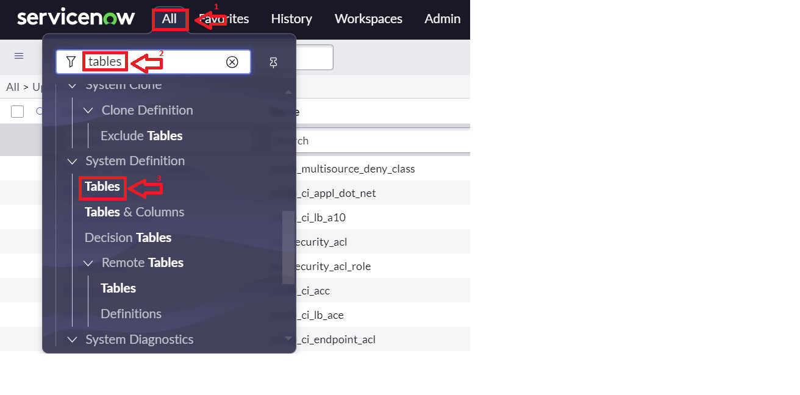

1. Then click on New.
2. Fill the Details as:

Label : Service Request

Name : Auto-Populated

Add module to menu : Select Create New

Leave everything as Default.

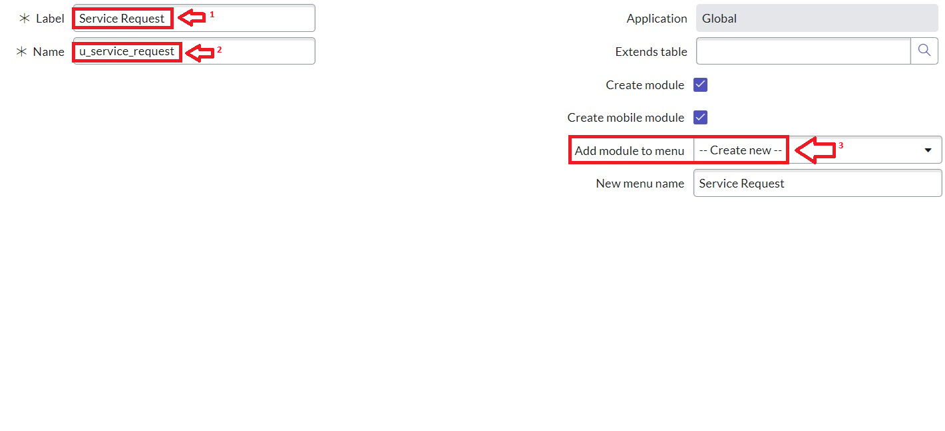

1. **Under Columns : click on insert a new row.**

**Column label : Name >> Type : String**

1. **Column label : Issue >>Type : String**

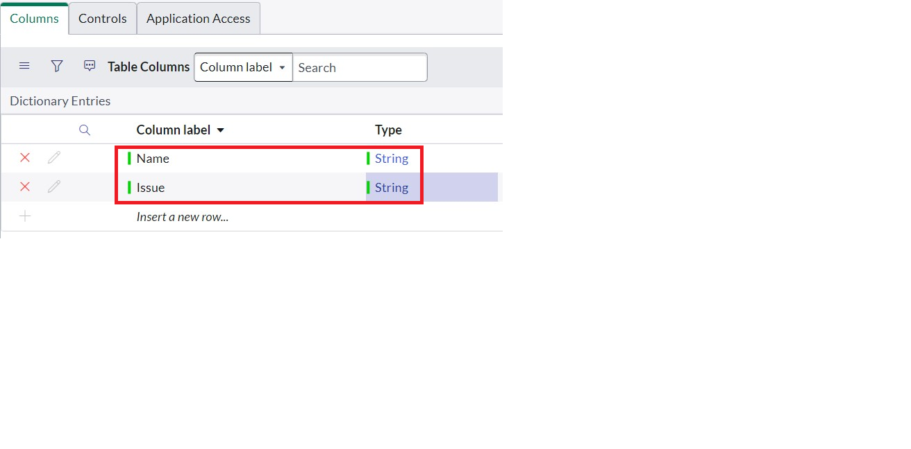

1. Click on Submit.

**Activity - 2: Create Users**

1. Open service now.
2. Click on All  >> search for users
3. Select Users under system security
4. Click on new
5. Fill the following details to create a new user

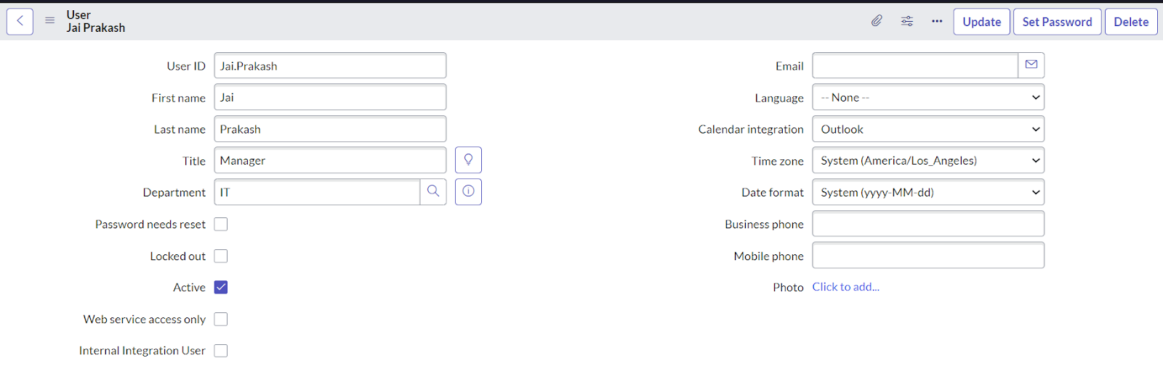

1. Click on Submit.

**Activity - 3: Create Groups**

1. Open service now.
2. Click on All  >> search for groups
3. Select groups under system security
4. Click on new
5. Fill the following details to create a new group.

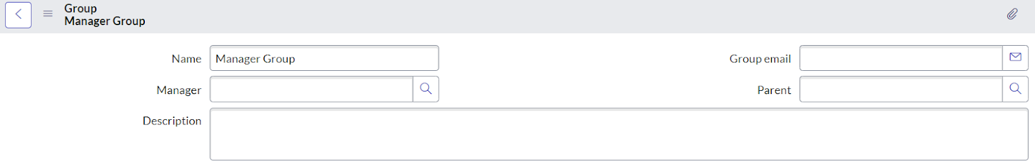

1. **Under Group Members, click on edit.**
2. **Add the user(Jai Prakash) to the Manager Group and click on Save.**
3. 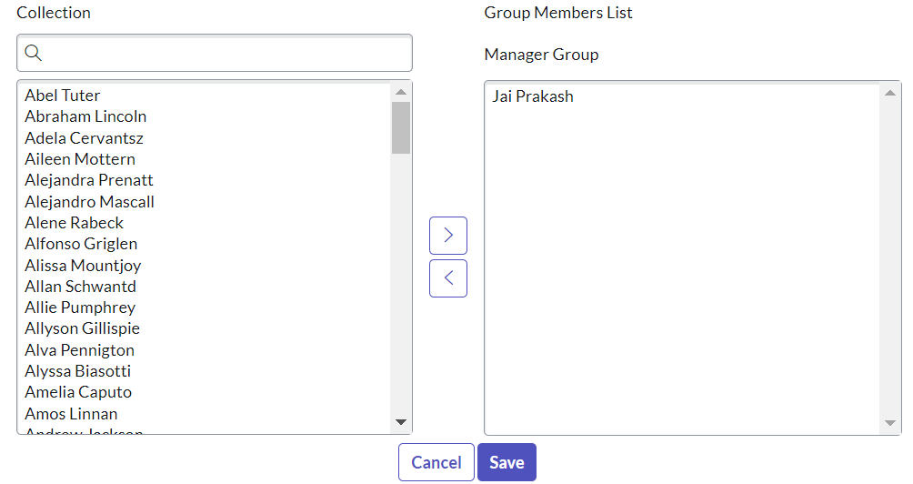
4. It would like below.

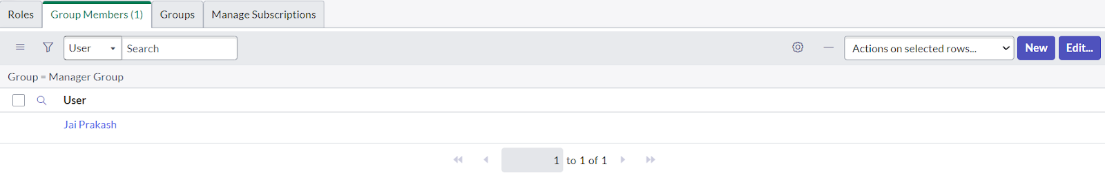

1. Click on save.

**Activity - 4: Create Roles**

1. Open service now.
2. Click on All  >> search for roles
3. Select roles under system security
4. Click on new
5. Fill the following details to create a new role

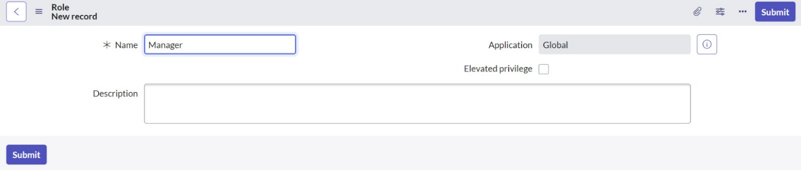

1. Click on Submit.
2. Click on All >> users
3. Search for “ jai prakash ”
4. Open the record, Go to the related list Click on roles
5. Click on Edit
6. Add manager to the selected list and Click in Save.

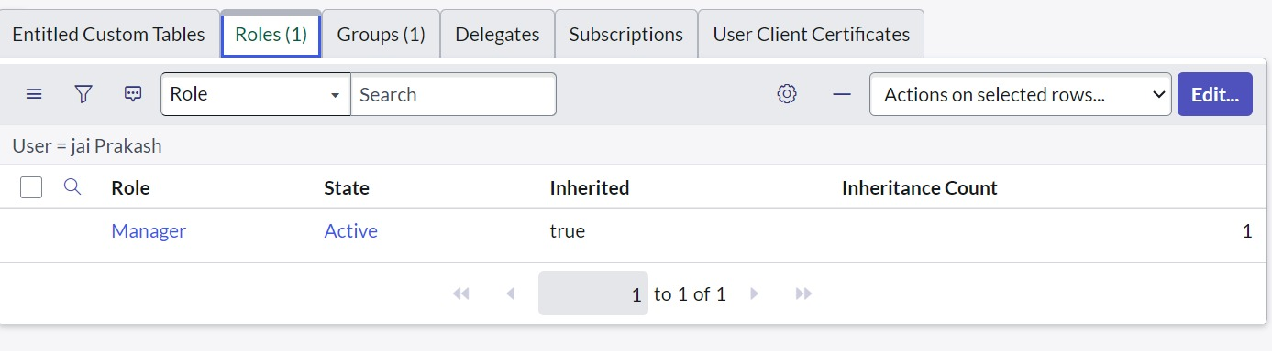

**Activity - 5: Creation of Modules**

1. Click on All.
2. Search for Application Menus.
3. Open Application Menus.

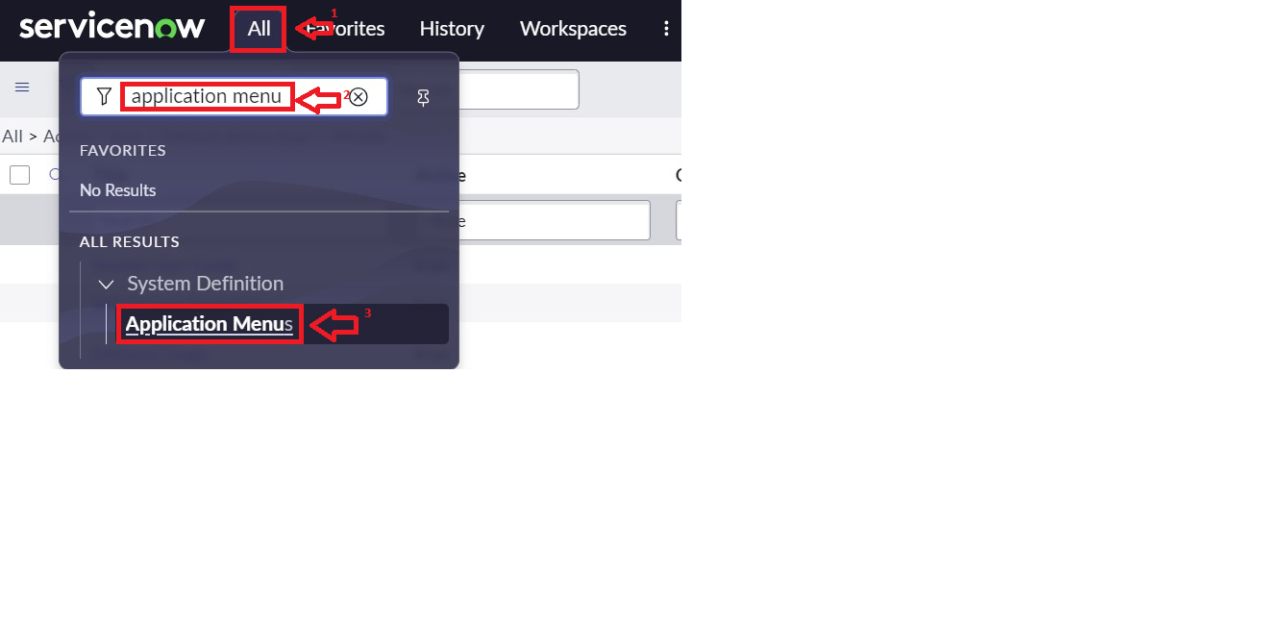

1. **Under Title search for Service Request and open service request**

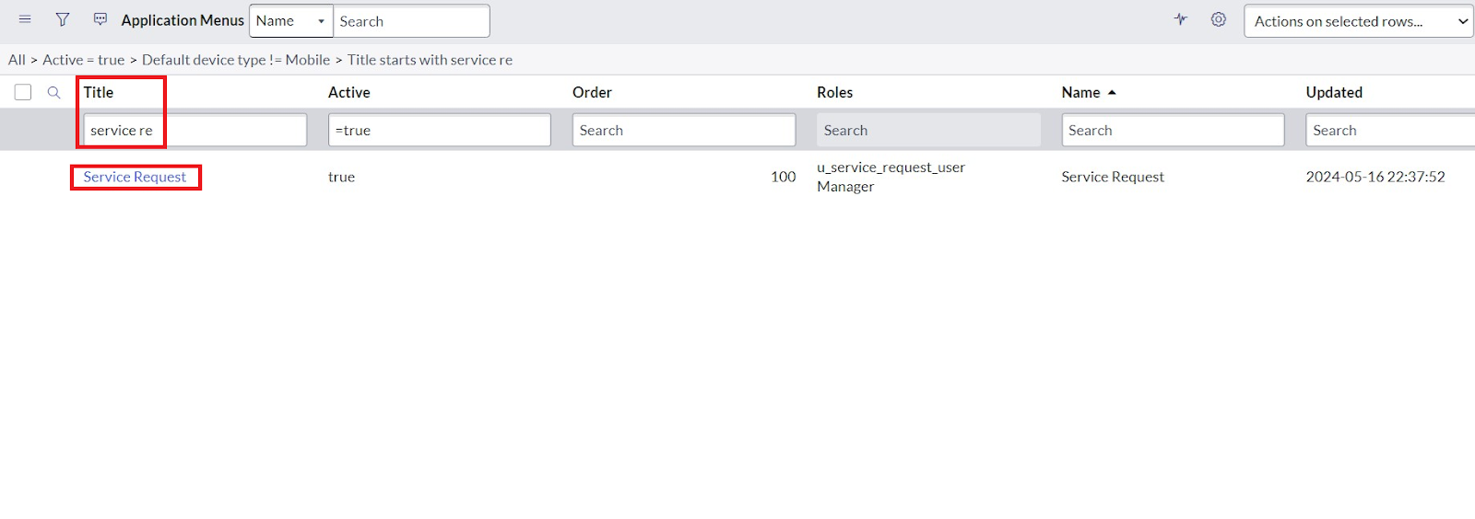

1. **Under Roles, click on roles and Select the Role to which this should be viewed.**

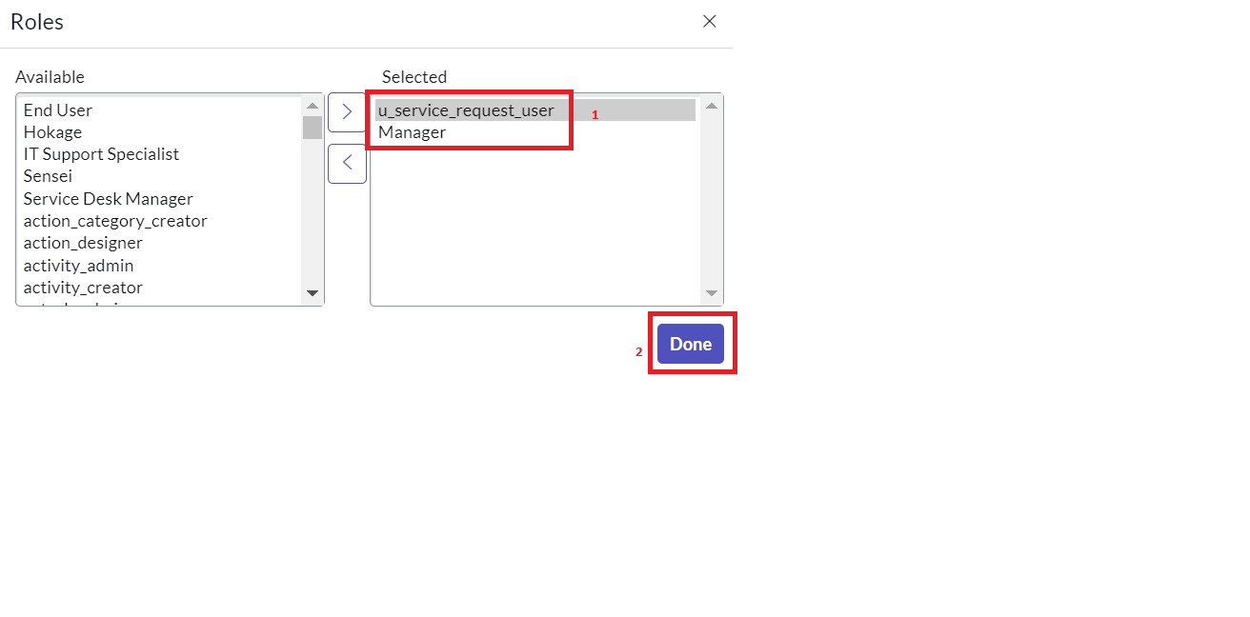

1. **Click on Done.**
2. **Now under Modules. Click on New**.

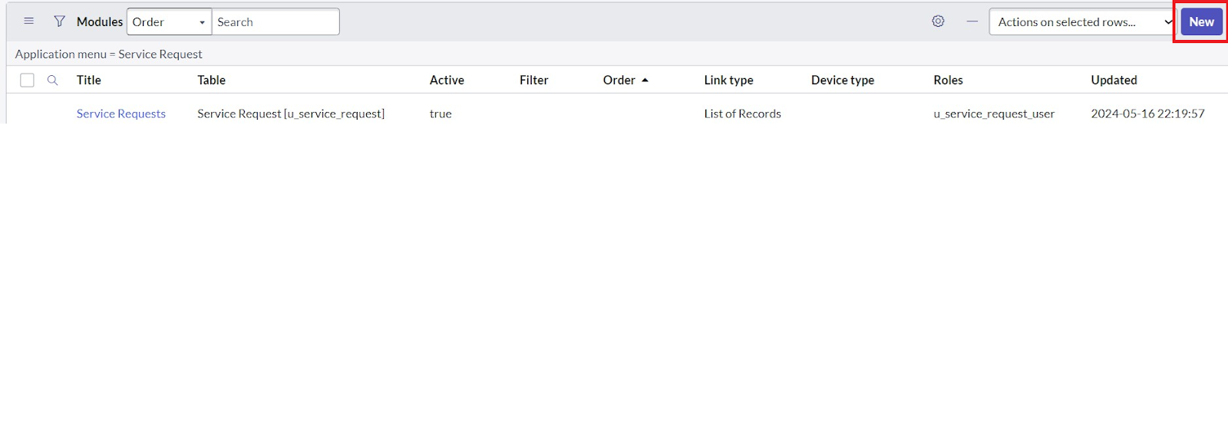

1. **Enter the details as:**

**Title : Create New**

1. **Under Visibility >> Select roles and select the role you want to assign.**

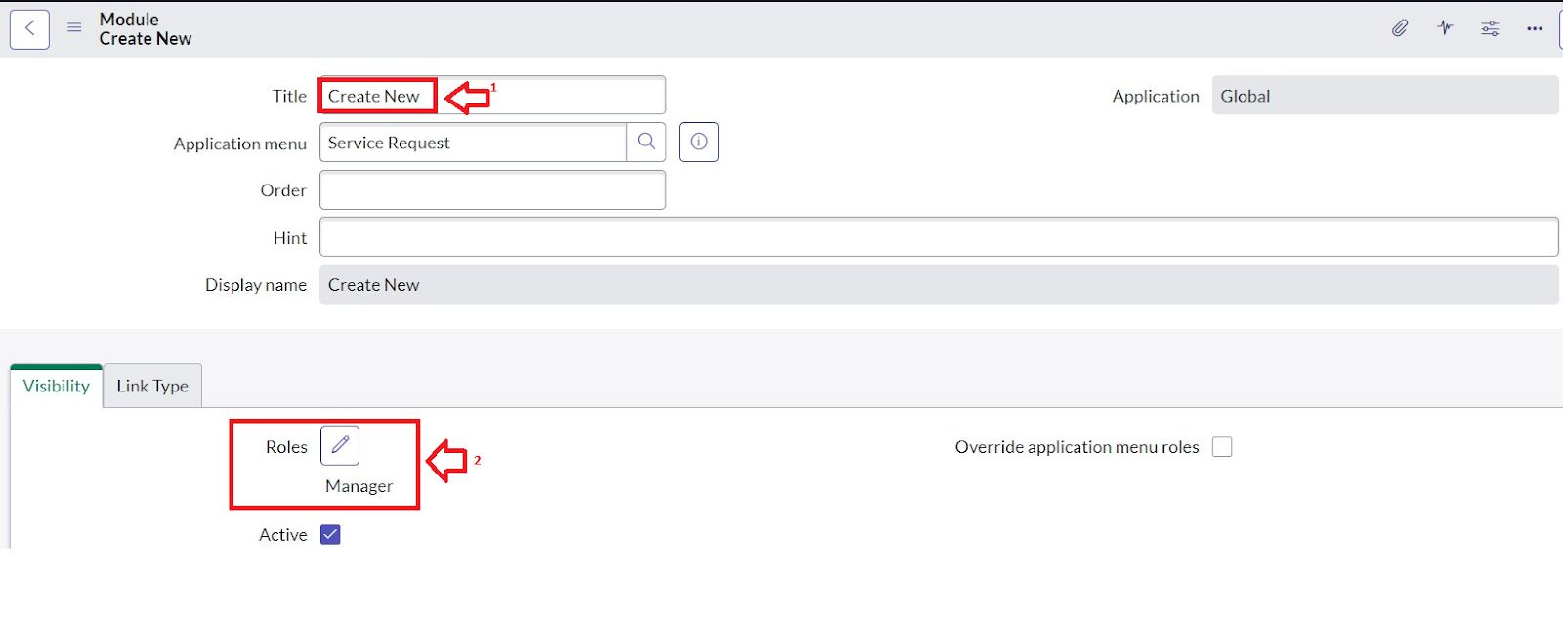

1. **In Link Type, fill details as shown in figure.**

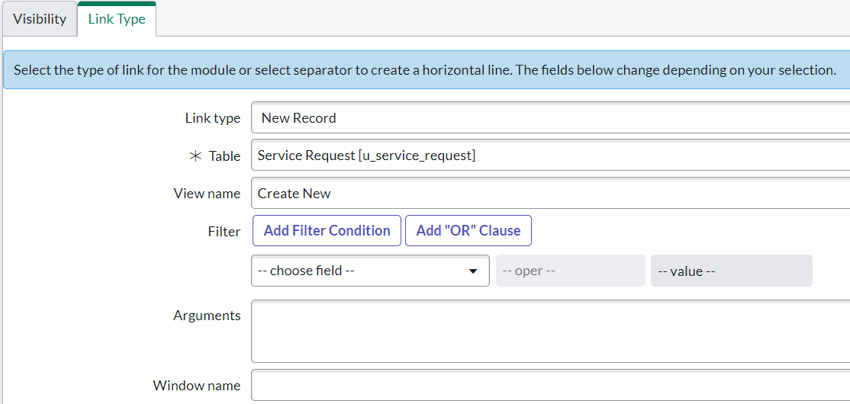

1. **Click on Save.**
2. **Now under Modules. Click on New.**



1. **Enter the details as:**

**Title : All**

1. **Under Visibility >> Select roles and select the role you want to assign**.

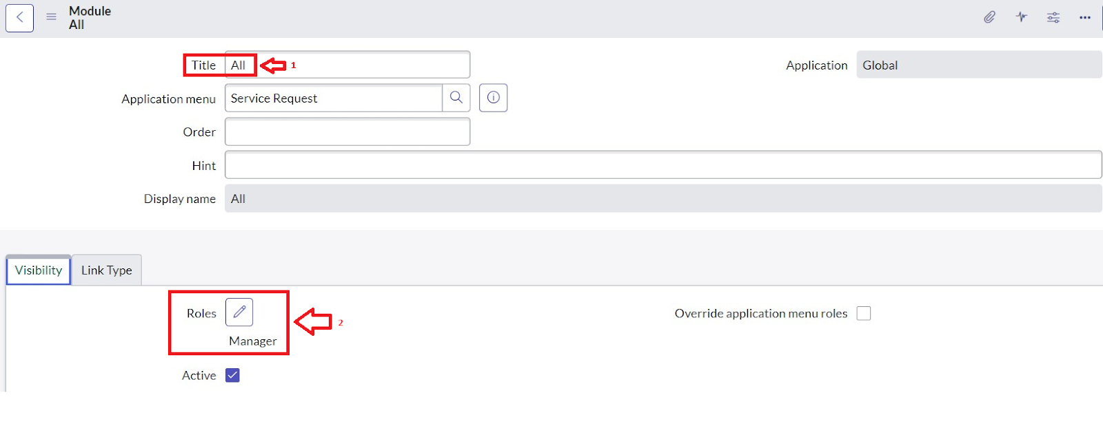

1. **In Link Type, fill details as shown in figure.**

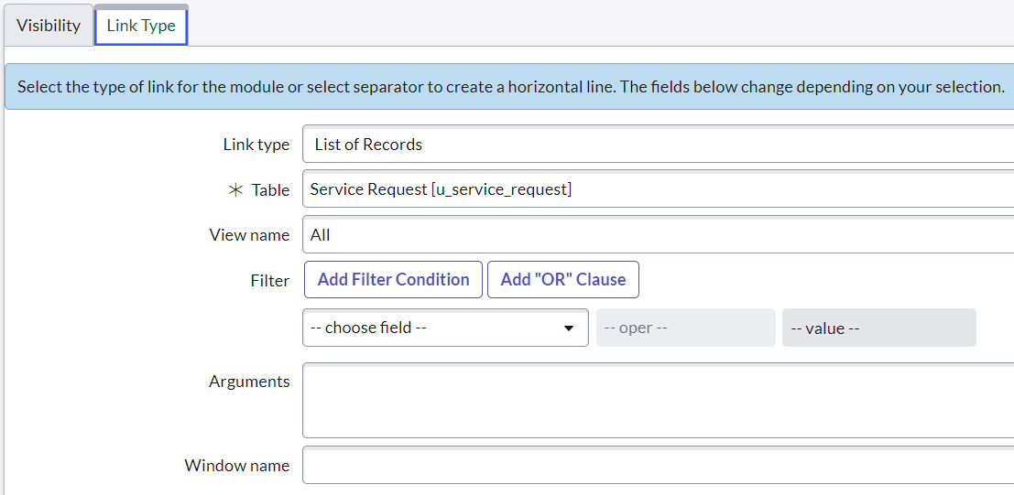

1. **Click on Save.**
2. **After that the Modules would look like below**.

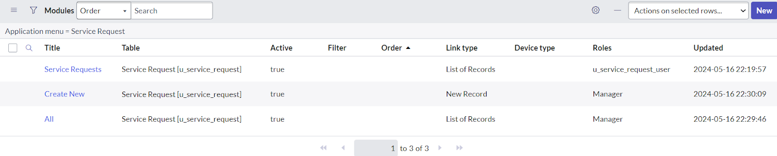

1. **Hover over to the top and double click on the context menu and click on the Save.**

**Key Scenarios Addressed by ServiceNow in the Implementation Project :**

In a ServiceNow implementation project, tailored application access plays a crucial role in enhancing the user experience by ensuring that the right people have access to the right resources and functionalities. ServiceNow’s platform offers various tools and capabilities to address key scenarios where application access needs to be customized to suit different user roles and business processes. Below are some key scenarios where ServiceNow can be used to implement tailored application access for improved user experience:

**1. Role-Based Access Control (RBAC)**

**Scenario**: Different users in an organization have varying levels of access to the system based on their job roles and responsibilities. For example, an HR representative may need access to employee records, while an IT technician may require access to incident management tools.

**Solution**: ServiceNow uses **Role-Based Access Control (RBAC)** to restrict access to specific applications, modules, and records based on user roles. By assigning roles to users, administrators can control who can access certain features or data. This ensures that users only see and interact with the information they need to perform their jobs effectively.

**Benefit**: Provides a tailored experience by ensuring users only see the relevant data and functionality, improving security and reducing information overload.

**2. Segregation of Duties (SoD)**

**Scenario**: In industries with strict regulatory requirements, segregation of duties is important to prevent conflicts of interest, such as ensuring that the same person cannot both create and approve financial transactions.

**Solution**: ServiceNow can be configured to enforce **Segregation of Duties (SoD)** rules. This allows organizations to define workflows and permissions that prevent users from having overlapping roles or access that could create conflicts or compliance risks.

**Benefit**: Enhances security and ensures compliance with internal policies and regulations while providing tailored access that aligns with an organization’s governance structure.

**3. Personalized Dashboards and Workspaces**

**Scenario**: Different users or departments within an organization need personalized views of data to perform their tasks efficiently. For example, a support agent might need a customized dashboard displaying their active incidents, while a manager might need a dashboard showing overall team performance metrics.

**Solution**: ServiceNow allows the creation of **personalized dashboards** and **workspaces**. These can be tailored to a user’s role and preferences, displaying relevant information in an intuitive and accessible manner. Users can personalize their own workspaces and dashboards, which can be configured by administrators as well.

**Benefit**: Improves the user experience by allowing users to access the data they need in the format they prefer, increasing efficiency and satisfaction.

**CONCLUSION:**

ServiceNow provides extensive capabilities to tailor application access based on user roles, organizational needs, and business processes. By leveraging role-based access controls, dynamic user interfaces, and other customization features, organizations can create a personalized, efficient, and secure user experience that meets the specific needs of each user group. Tailored access not only enhances productivity but also ensures compliance and security, providing a streamlined and effective platform for both end-users and administrators.